Kazakh-British Technical University
Data collection and preparation

Laboratory work №1

Reading and Converting Formats

Full Name: Baibolov Sultanmakhmut
ID: 23B031235

08.09.2026
Almaty

Table of contents
Task 1. Dataset selection 3
Task 2. Data-quality analysis 5
Task 3. Data formats 4
Task 4. Data format comparison 4

Task 1. Dataset selection
Select an open dataset from Kaggle, Data.gov, World Bank Open Data, UN Data or another open source. The dataset must contain at least 100 rows, five columns and at least one data-quality problem.

- Dataset name and source link
Dataset name - Netflix Movies and Series
Source link - https://www.kaggle.com/datasets/debayank2024/netflix-movies-and-series?resource=download

- Author
Author - Debayan Bandyopadhyay (https://www.kaggle.com/debayank2024)

- Number of rows and columns
Rows – 8807
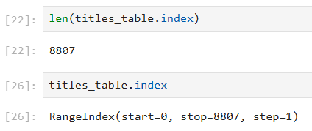
Columns - 12
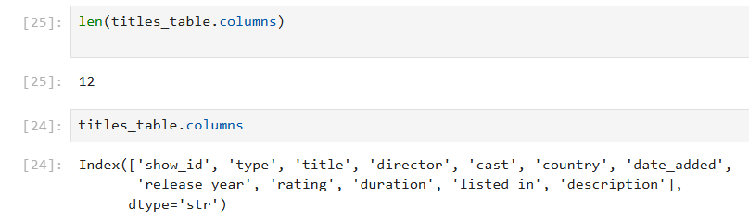
- Meaning of 1 row and each column
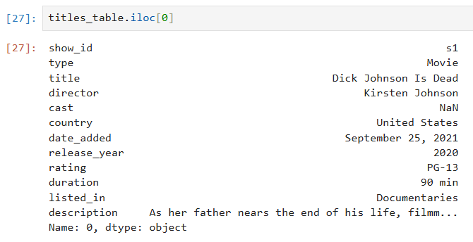
- show_id –title id,
- type –title type (Movie/TV Show),
- title –name of the title,
- director –directors separated by commas (NaN if unknown),
- cast – list of actors separated by commas,
- country – production country,
- date_added – the Netflix adding date,
- release_year – release year,
- rating – content rating (https://en.wikipedia.org/wiki/Content_rating),
- duration – duration of the title (“X min” for movies and “X Seasons” for TV Shows),
- listed_in – title genres and tags (e. g. Dramas, International Movies),
- description – title description.

- Dataset type
Structured

Task 2. Data-quality analysis
Identify the data types, missing values, duplicates, invalid values, inconsistent categories, incorrect date or number formats, and possible outliers. Present the results in a table containing the column name, identified problem, example, and its possible effect on further data analysis.

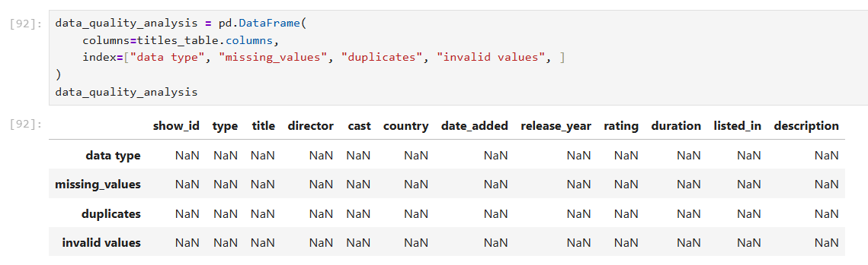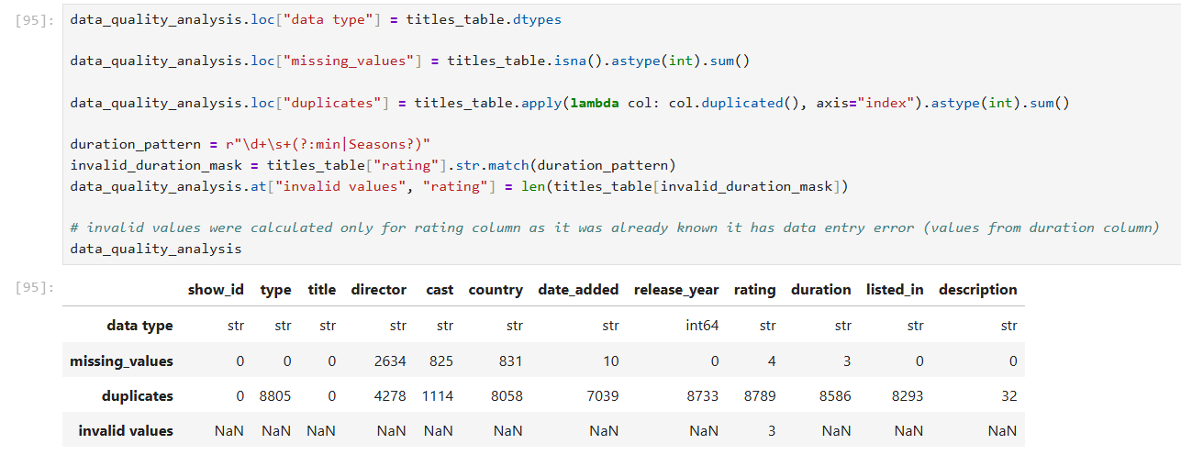

Column name | Identified problem | Example | Possible effect on further data analysis
date_added | Data type is str, string representation is unusual | “September 25, 2021” | Incorrect sorting, validation errors, broken date manipulation
rating
Others

